Puzzles which can be used in Lily:

* Slide puzzle

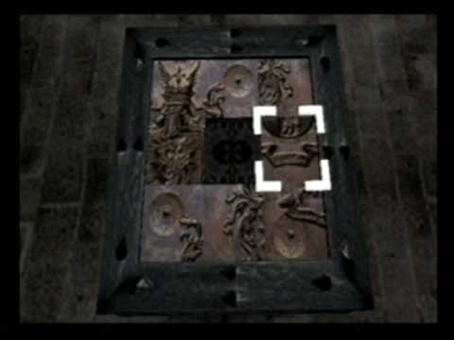

* Item search (hidden object)

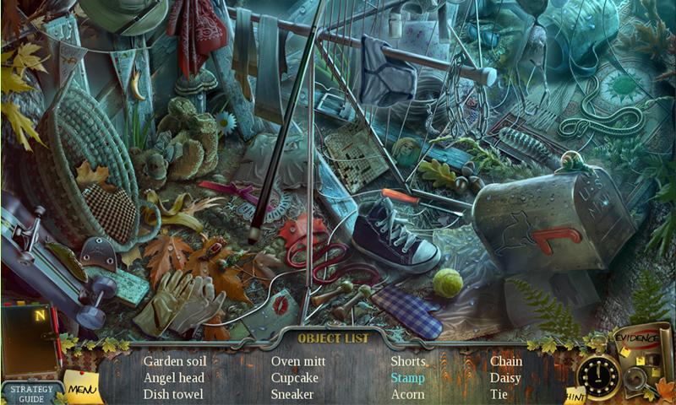

* Pathway (turn arrows around to make a path to unlock a door etc)

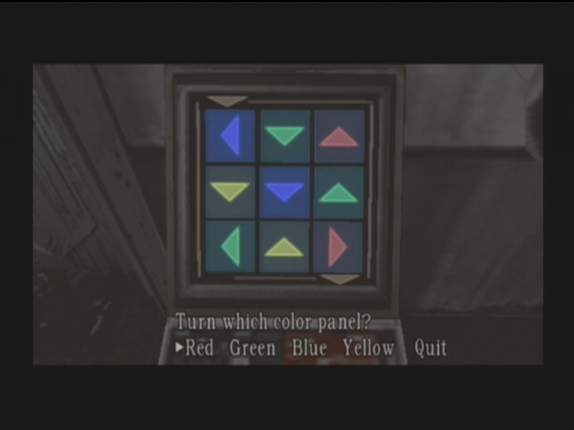

* Standard jigsaw puzzle

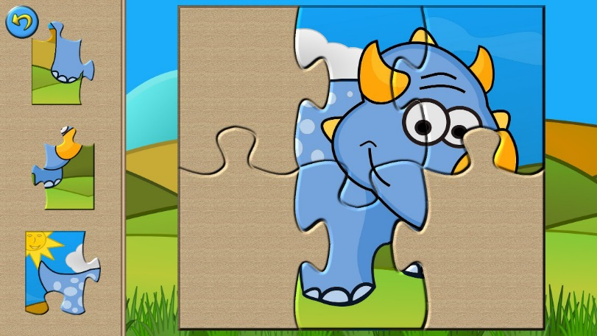

* Riddles (hints to collect an item from a room and use it to unlock the door)
* Celtic knot puzzle

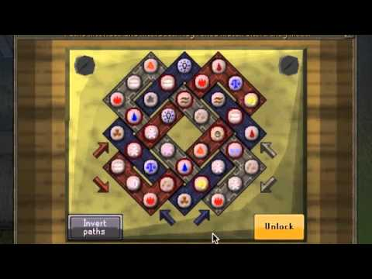

* Clue scrolls

Go to an area, pick up a new clue, solve that one etc until you find the last one which gives an answer/ reward.